Dearinger & Klindt CCC, PLLC
107 N. 5th Street
Bardstown, KY 40004
Phone: 502-348-3202 Fax: 502-348-0321

CONFIDENTIAL PATIENT INFORMATION

How did you hear about our office?____________________________________________________________________

First Name: _______________________ MI: _____ Last Name: _____________________________________________

Address: __________________________________________________________________________________________

City: _______________________________________ State: ___________________ Zip: _________________________
Home Phone: ______-______-_______Work Phone: ______-______-_______ Cell Phone: ______-______-___________
Email Address: __________________________________ Employer: _________________________________________
Date of Birth: _________________ Social Security #: _______-______-_______ Gender: M - F Shoe size: _______
Preferred Language: ______________________ Ethnicity: ______________________ Race: ______________________
Marital Status: Married - Single - Widowed - Student
Name of Spouse: ______________________________________ Spouse's DOB: _______________________________
Spouse's employer: ____________________________________ Spouse's SS number: ___________________________
List any Allergies:
 Animals  Aspirin  Bees  Chocolate  Dairy  Dust  Eggs Latex  Molds  Penicillin  Ragweed/Pollen
 Rubber  Seasonal Allergies  Shellfish  Soaps  Wheat  X-Ray Dye  Other: ____________________________
List any Surgeries:
 Back  Brain  Elbow  Foot  Hip  Knee  Neck  Neurological  Shoulder  Wrist  Other: ______________
List ALL Past Medical History conditions:
 Ankle Pain  Arm Pain  Arthritis  Asthma  Back Pain  Broken Bones  Cancer  Chest Pain  Depression
 Diabetes  Dizziness  Elbow Pain  Epilepsy  Eye/Vision Problems  Fainting  Fatigue  Foot Pain
 Genetic Spinal Condition  Hand Pain  Headaches  Hearing Problems  Hepatitis  High Blood Pressure
 Hip Pain  HIV  Jaw Pain  Joint Stiffness  Knee Pain  Leg Pain  Menstrual Problems  Mid-Back Pain
 Minor Heart Problem  Multiple Sclerosis  Neck Pain  Neurological Problems  Pacemaker  Parkinson’s
 Polio  Prostate Problems  Shoulder Pain  Significant Weight Change  Spinal Cord Injury  Sprain/Strain
 Stroke/Heart Attack  Other: ________________________________________________________________________
List Type of Medications you are taking:
 Anxiety  Muscle Relaxers  Pain Killers  Insulin  Birth control  Cardiovascular  Allergy  Seizure
 Other: _________________________________
Medication Allergies: ________________________________________________________________________________
List your Family History:
 Arthritis  Asthma  Back Pain  Cancer  Depression  Diabetes  Epilepsy  Genetic Spinal Condition
 High Blood Pressure  Heart Problems  Multiple Sclerosis  Neurological Problems  Parkinson’s  Polio
 Prostate Problems  Stroke/Heart Attack  Other: _______________________________________________________
Please list family member with this medical history (ex. mother, father etc.)
__________________________________________________________________________________________________
__________________________________________________________________________________________________
__________________________________________________________________________________________________ OVER
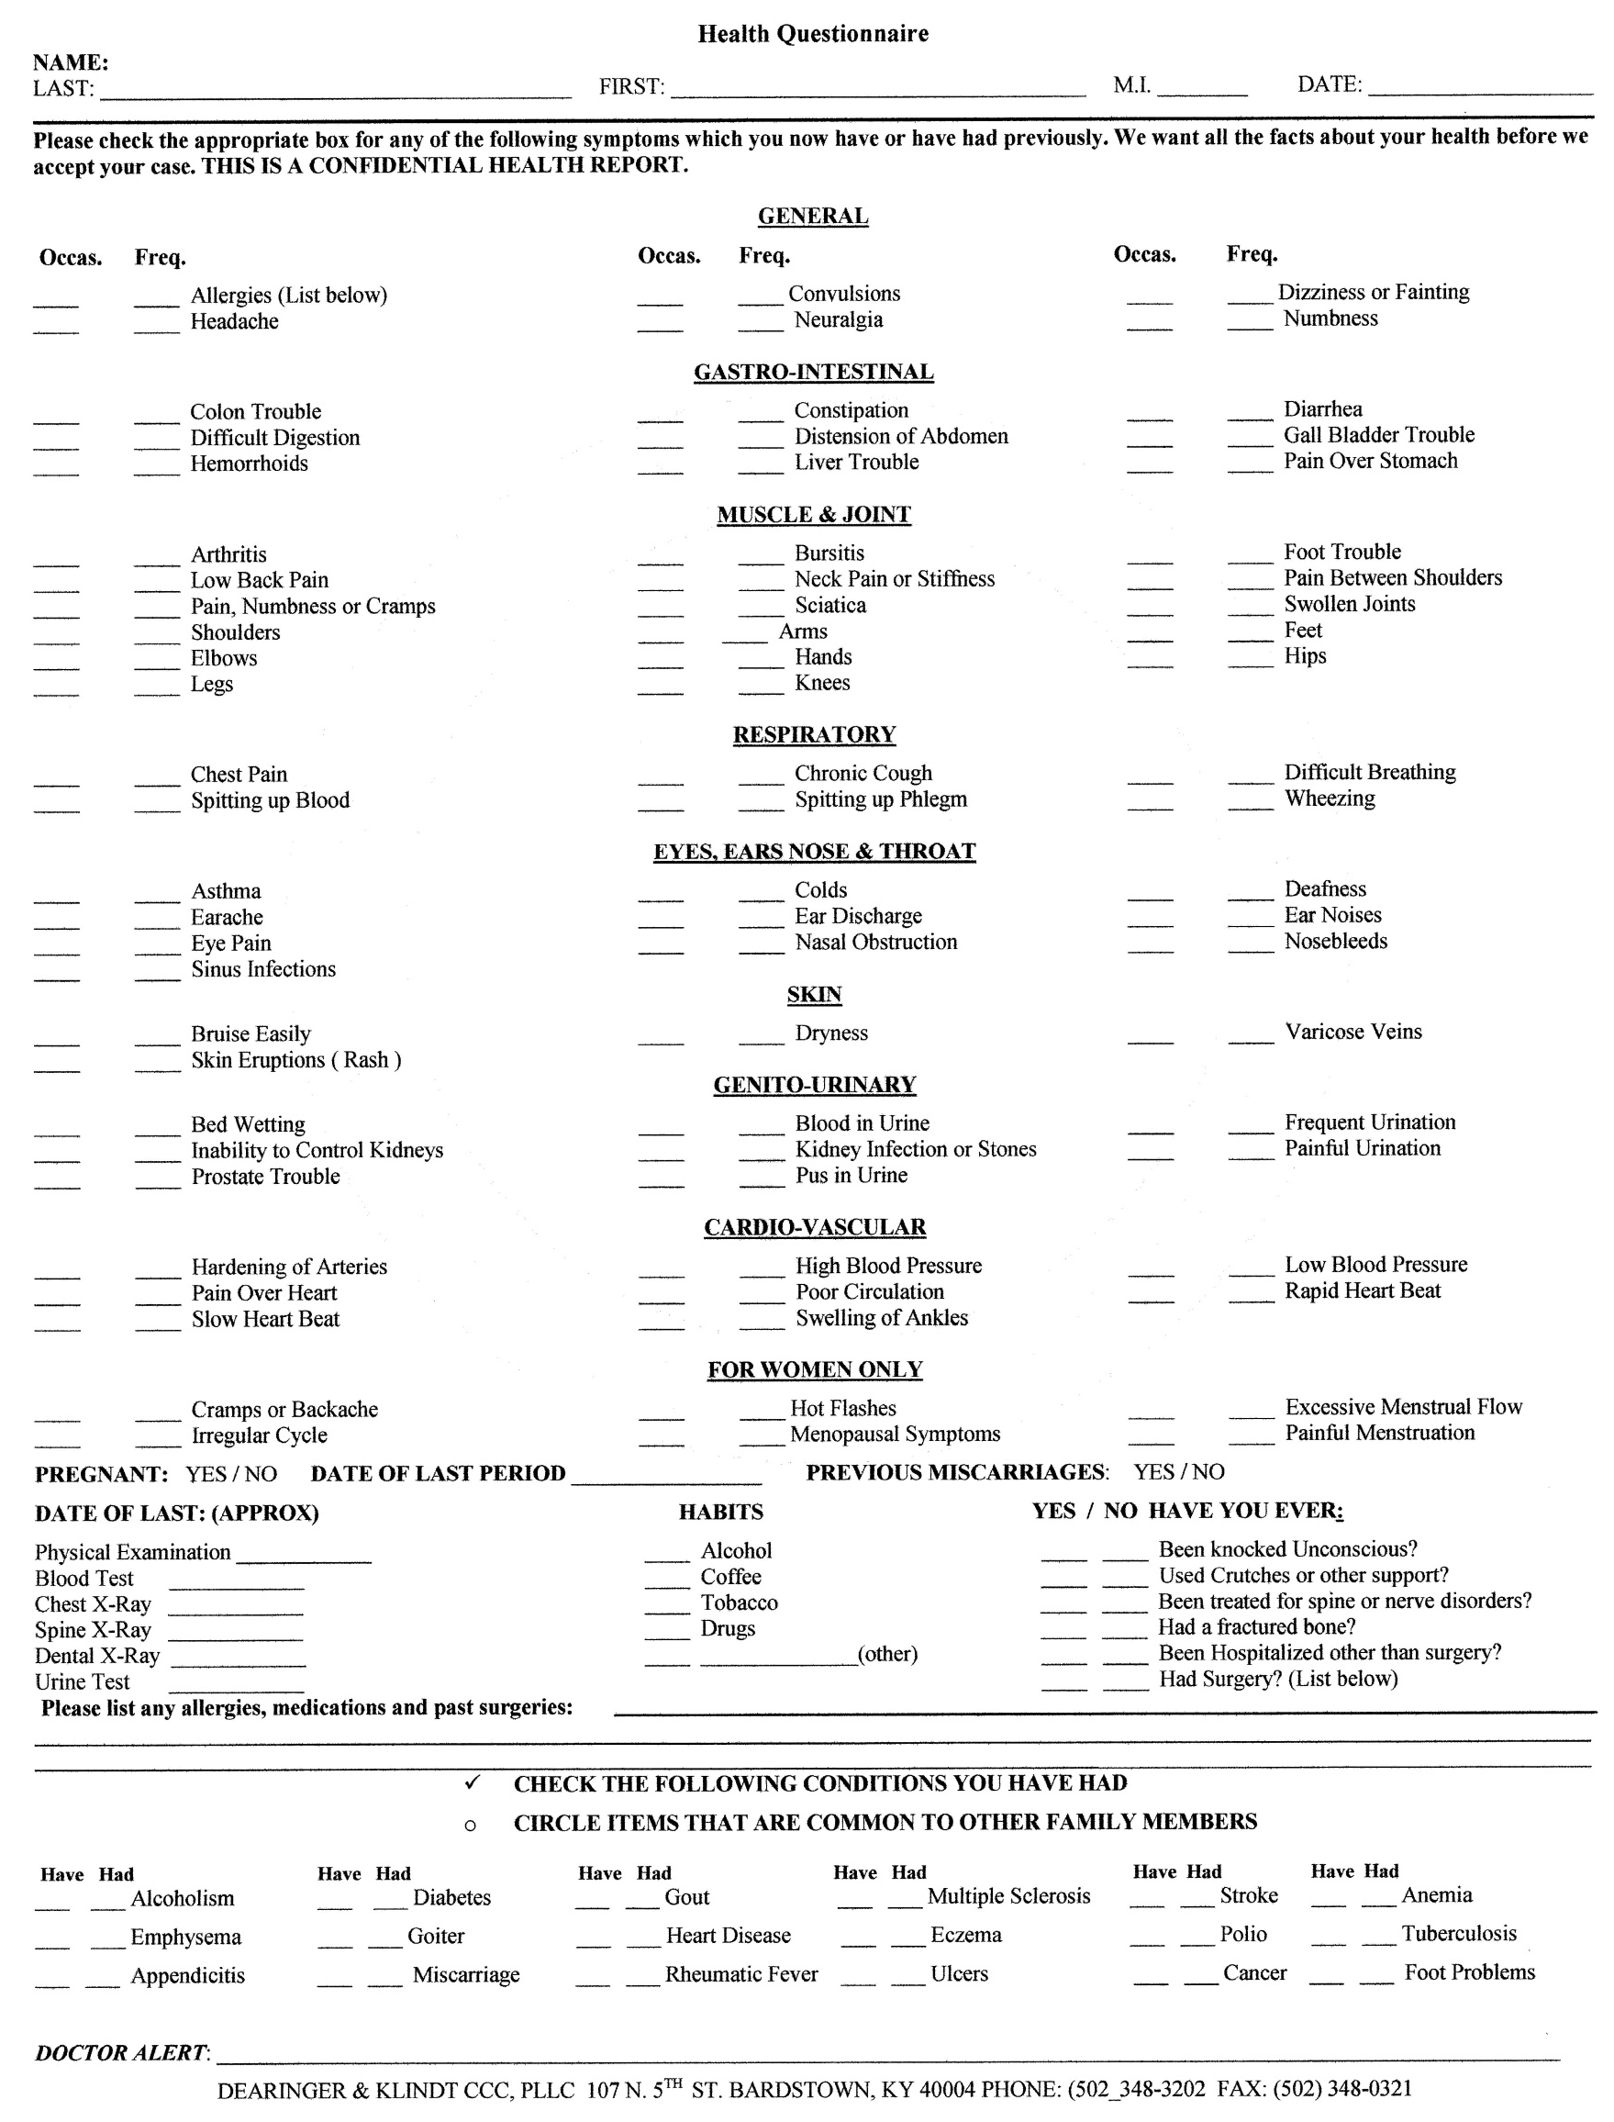

Have you had any auto or other accidents?  No Yes Describe: ___________________________________________________________________________________
Date of last physical examination: _________________ Do you smoke?  No Yes
Do you drink alcohol?  No Yes - how many per day? _________________
Do you drink caffeine?  No Yes - how many per day? _________________
Do you exercise?  No Yes (what forms and how often): ___________________________________________________

Main reason for consulting the office:

 Become pain free
 Explanation of my condition
 Learn how to care for my condition
 Reduce symptoms
 Resume normal activity level

What is your major complaint? _______________________________________Date problem began? ________________
Which side? Right Left Both
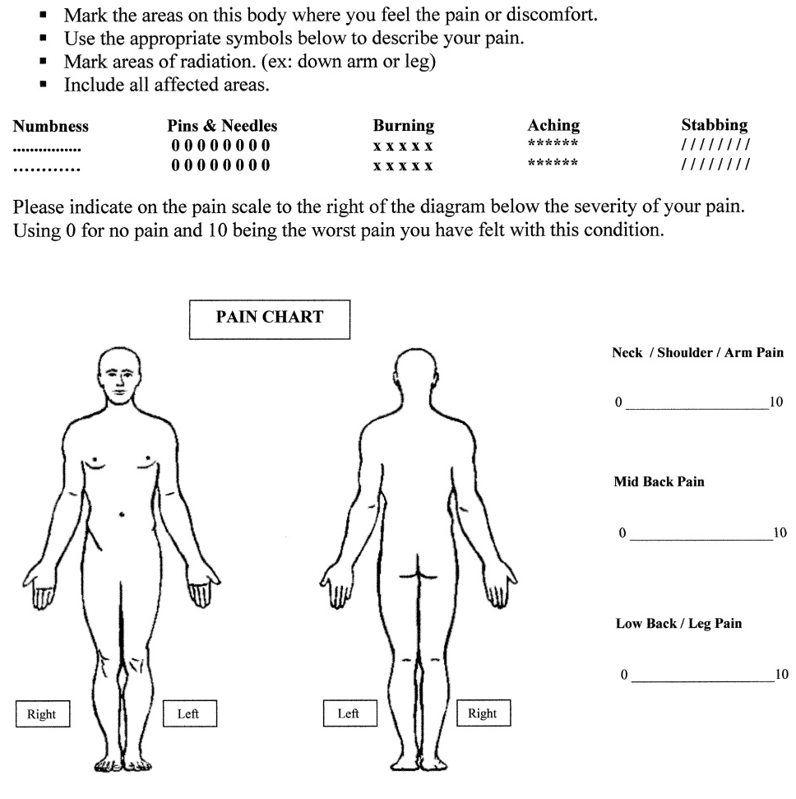
How did this problem begin (falling, lifting, etc.)? ____________________________________________________________

PLEASE MARK YOUR AREAS OF PAIN ON THE DIAGRAM BELOW

How is your condition changing?  GETTING BETTER  GETTING WORSE  NOT CHANGING
Have you had this condition in the past? YES - NO
How often do you experience your symptoms?
 Constantly (76-100% of the day)  Frequently (51-75% of the day)
 Occasionally (26-50% of the day)  Intermittently (0-25% of the day)
Describe the nature of your symptoms:  Sharp  Dull  Numb  Burning  Shooting  Tingling  Radiating Pain
 Tightness  Stabbing  Throbbing  Other: ______________________________________________________________
Please rate your pain on a scale of 1 to 10 (0= no pain and 10= excruciating pain)
 1  2  3  4  5  6  7  8  9  10
How do your symptoms affect your ability to perform daily activities such as working or driving?
(0= no effect and 10= no possible activities)  1  2  3  4  5  6  7  8  9  10
What activities aggravate your condition (working, exercise, etc)? _______________________________________________
What makes your pain better (ice, heat, massage, etc)? ________________________________________________________

What is your SECOND complaint? _________________________________Date problem began? ___________________
Which Side? Right Left Both
How did this problem begin (falling, lifting, etc.)? ____________________________________________________________
How is your condition changing?  GETTING BETTER  GETTING WORSE  NOT CHANGING
Have you had this condition in the past? YES - NO
How often do you experience your symptoms?
 Constantly (76-100% of the day)  Frequently (51-75% of the day)
 occasionally (26-50% of the day)  Intermittently (0-25% of the day)
Describe the nature of your symptoms:  Sharp  Dull  Numb  Burning  Shooting  Tingling  Radiating Pain
 Tightness  Stabbing  Throbbing  Other: ___________________________________________________________
Please rate your pain on a scale of 1 to 10 (0= no pain and 10= excruciating pain)
 1  2  3  4  5  6  7  8  9  10
How do your symptoms affect your ability to perform daily activities such as working or driving?
(0= no effect and 10= no possible activities)  1  2  3  4  5  6  7  8  9  10
What activities aggravate your condition (working, exercise, etc)? _____________________________________________
What makes your pain better (ice, heat, massage, etc)? ______________________________________________________

I understand and agree that health and accident insurance policies are an arrangement between an insurance carrier and myself. I authorize payment from my insurance carrier directly to this office with the understanding that all monies will be credited to my account upon receipt. However, I clearly understand and agree that all services rendered me are charged directly to me and that I am personally responsible for payment. I also understand that if I suspend or terminate my care and treatment, fees for professional services rendered me will be immediately due and payable. In the event of default I promise to pay legal interest on indebtedness together with such collection costs and reasonable attorney fees as may be require to effect collection.

Signature: _____________________________________ Date: ____________________________________

